# **PHP Using Instruction**

1. **Instruction to run:**
2. **Create database:**

+ The application is running locally (xampp was used as web-server).

+ Xampp is supposed to be run (Apache, MySQL need to be run).

+ Access to phpMyAdmin, and create a database named “phptest”.

1. **Create table and data:**

+ Get access to the root path of the project (within “phptest” folder).

+ (Shift + Right) click anywhere inside this folder and choose “Open PowerShell window here”.

+ Once the PowerShell displays, enter these two below commands:

* “php artisan migrate”
* “php artisan db:seed”

+ The table named “stock” will be supposed to be displayed inside “phptest” database along with its data.

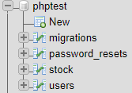

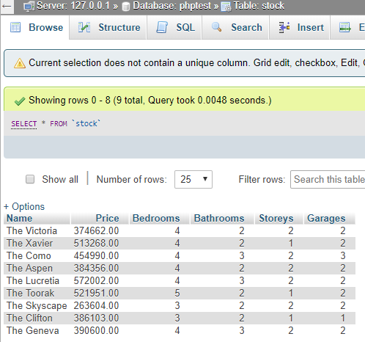

1. **Running the webpage with specific route named “db_search”:**

+ Open the web browser and enter the path onto browser’s url:

<http://localhost/phptest/public/db_search>

+ The page is supposed to start with as the screenshot below:

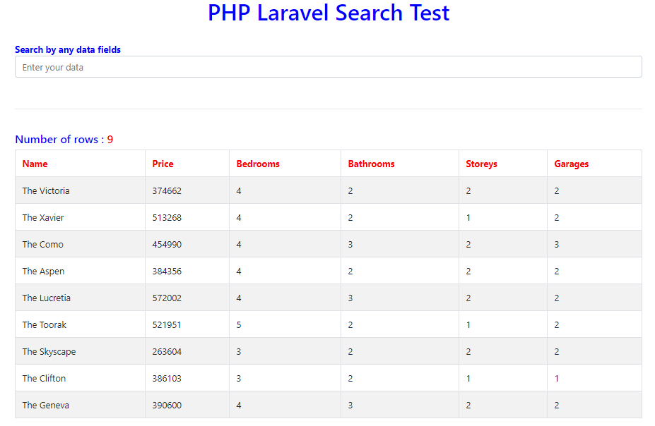

1. **Using search function:**

**+** The app is used ajax, and the result will be display instantly as soon as the corresponding data is entered in the search text field without page reloading.

1. **Task limitation:**

+ The search function is not yet implemented to search with many parameters at once as requirements such as 4 bedrooms and 2 bathrooms, or with a price range between two numbers.

+ It is now only able to search with a single variable. And the data in this search field are any ones stored in the “stock” table. When we input a specific data, then the data will be searched on whether it will satisfy the searching requirement for every kind of data fields (such as Name, Price, Bedrooms, Bathrooms, Storeys, Garages).

+ The API is not yet implemented with Vue.js